=============================================================================

**Web Villas**

Project Εξαμήνου

==============================================================================

# **Home page – index**

**Public View**

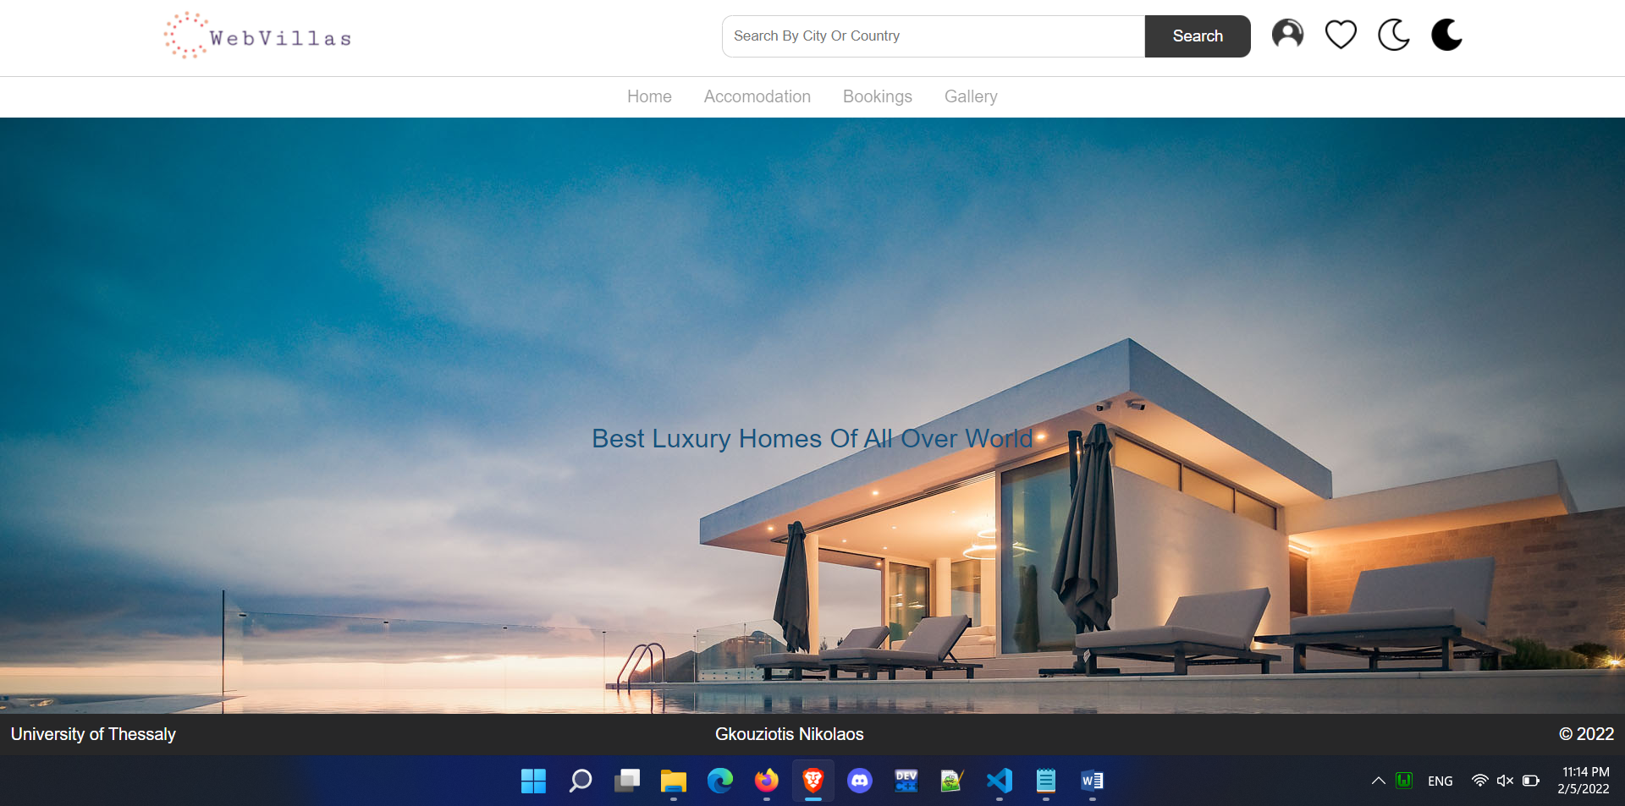

**User page**

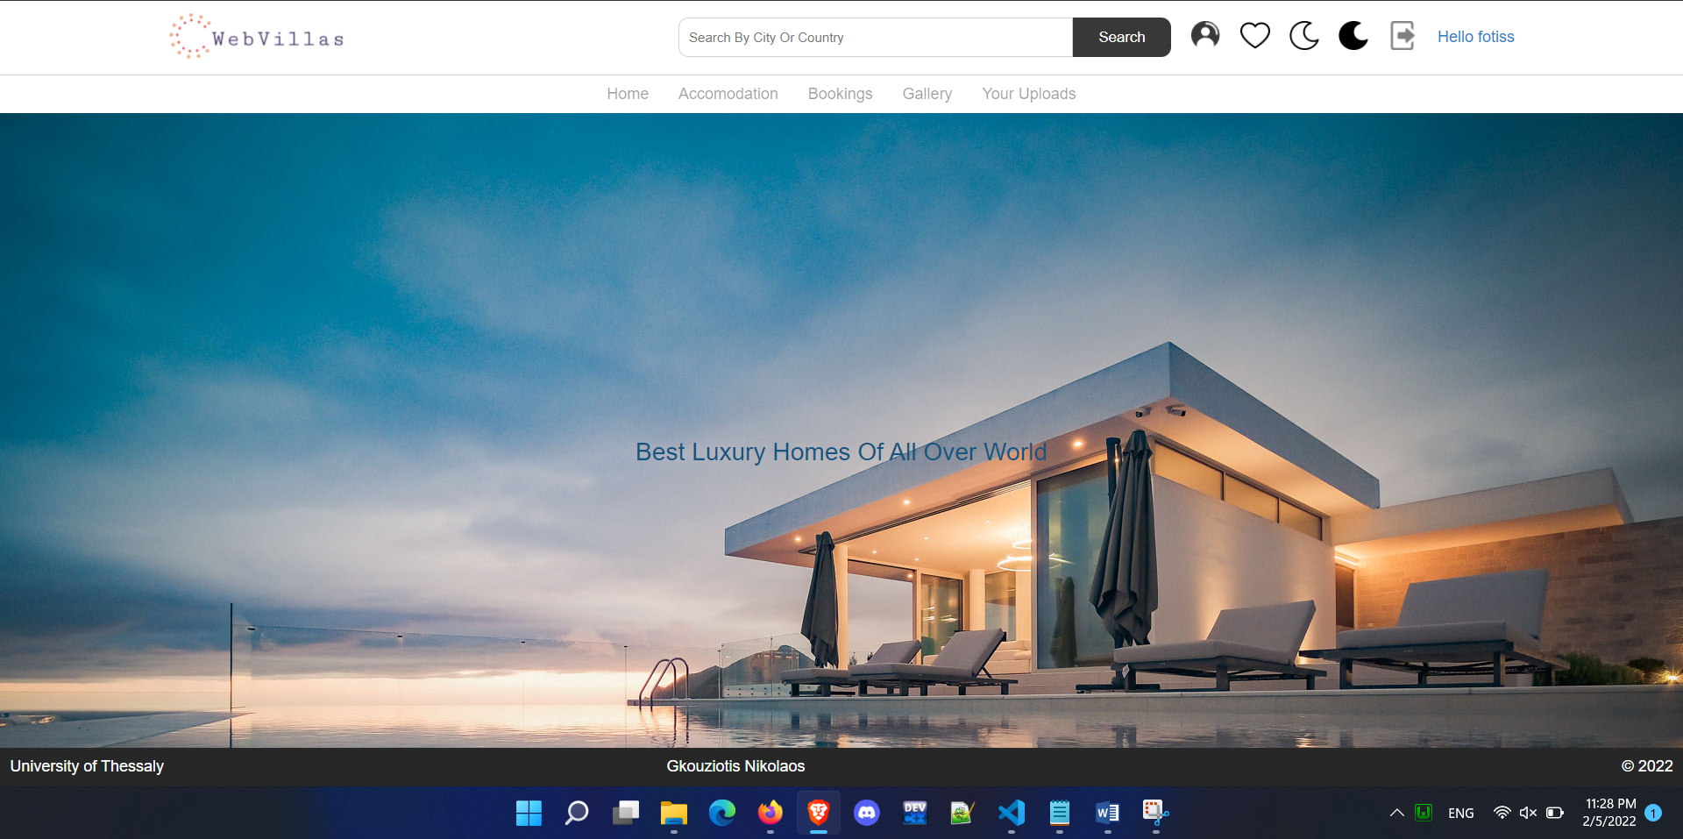

**Form – Log In**

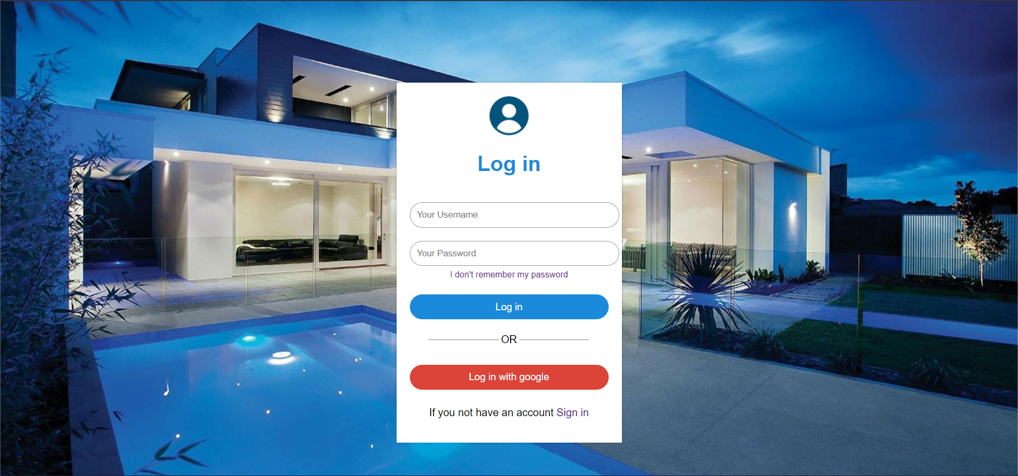

**Form – Log In Λαθος στοιχεία**

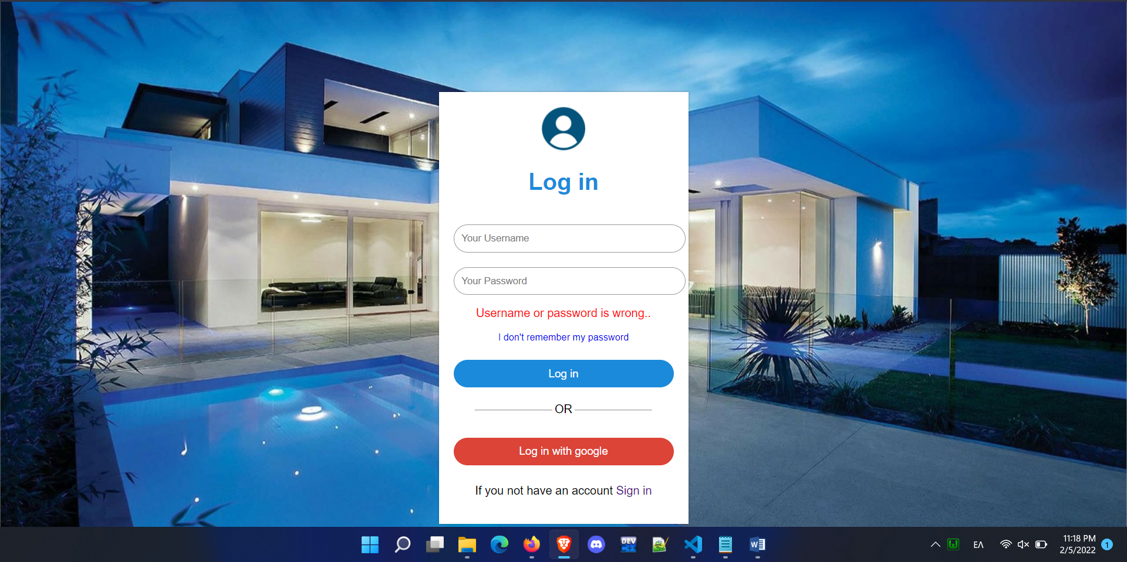

**Form – Sign Up**

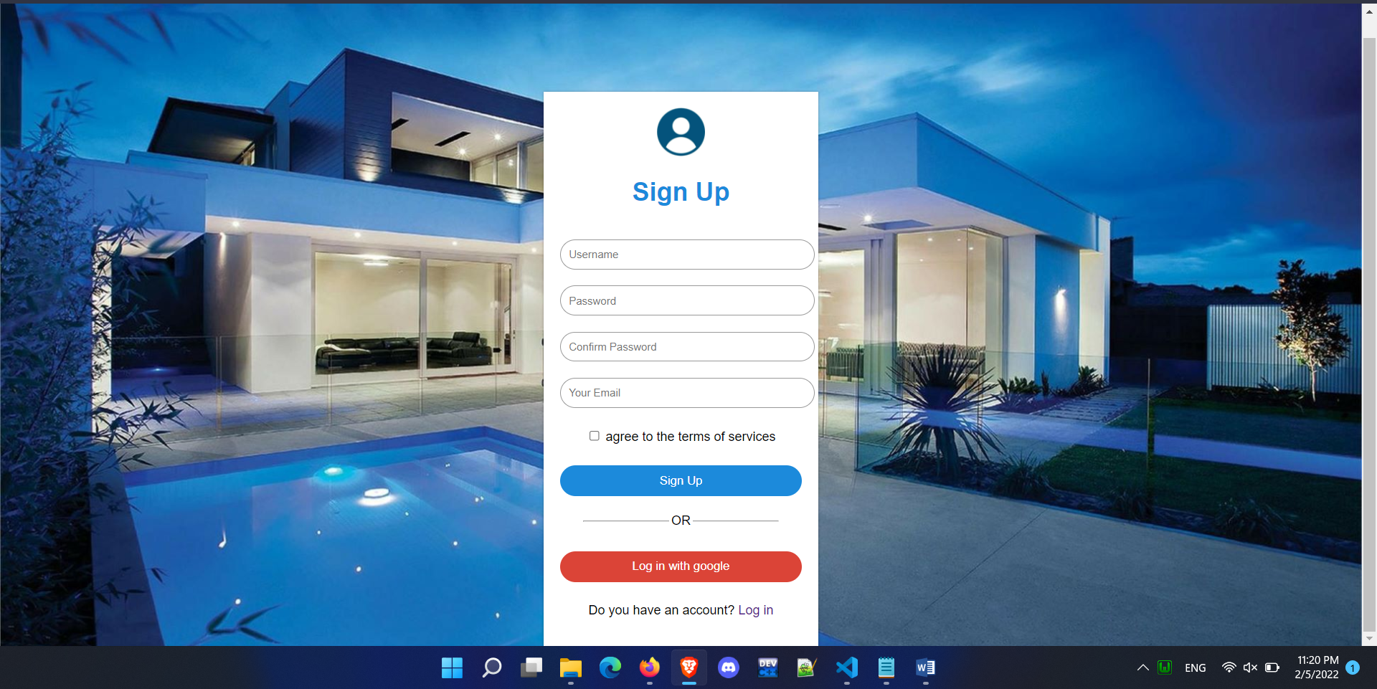

**Form – Sign Up : Ίδιο username**

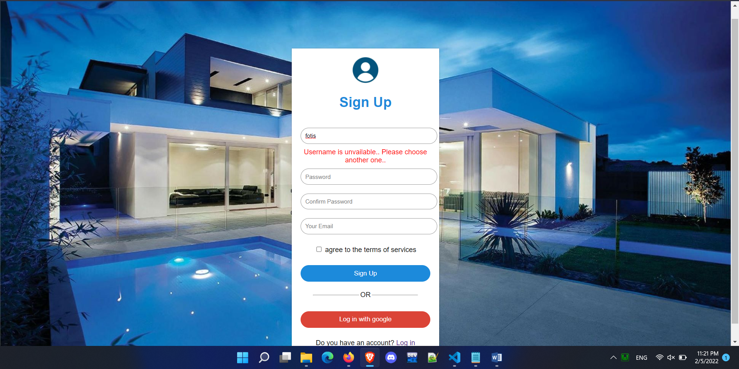

**Form – Sign Up : password wrong**

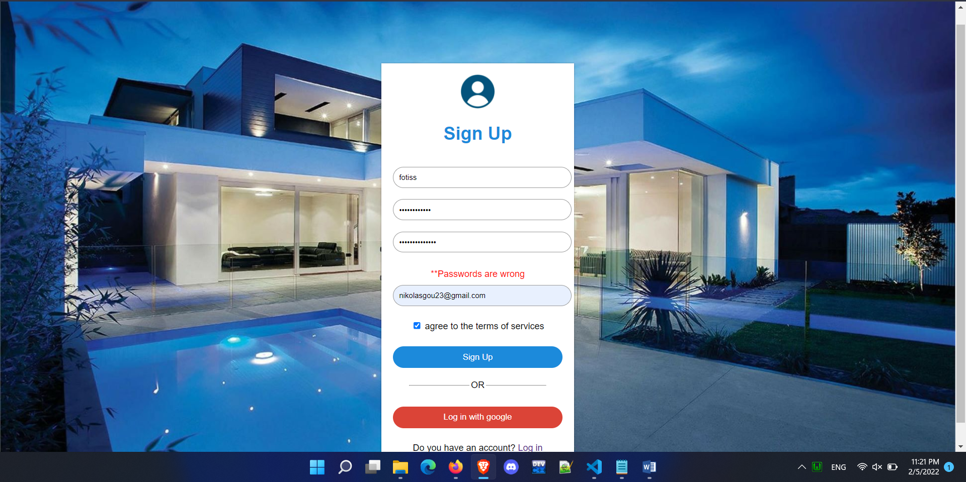

**Form – Sign Up : email wrong**

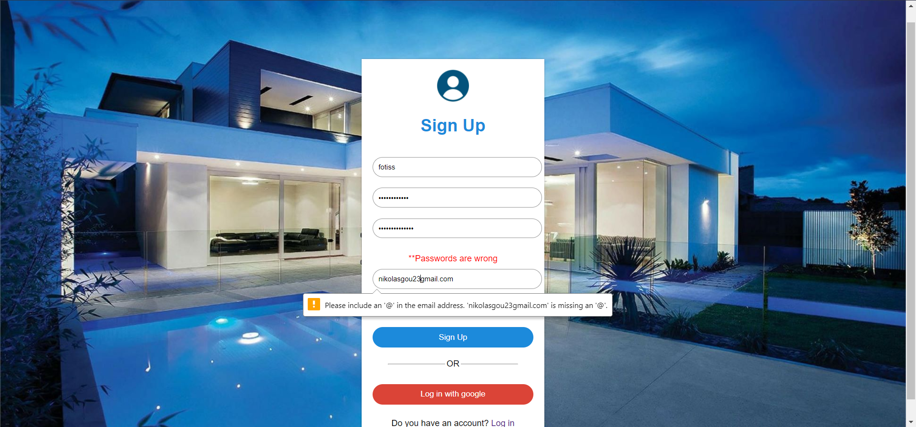

**Form - Email Verification**

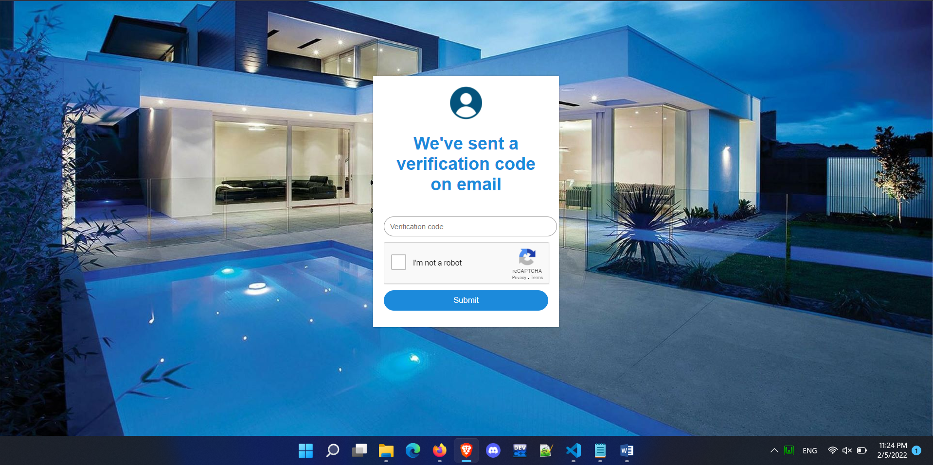

**Email sended**

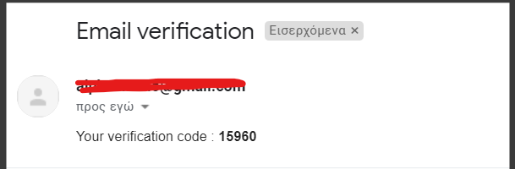

**Email Verification – Wrong Verfication code**

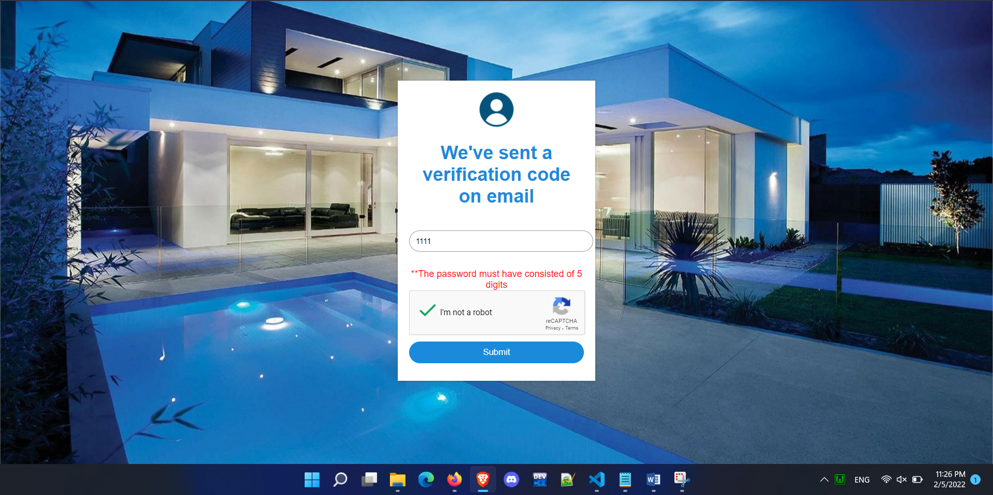

**Gallery**

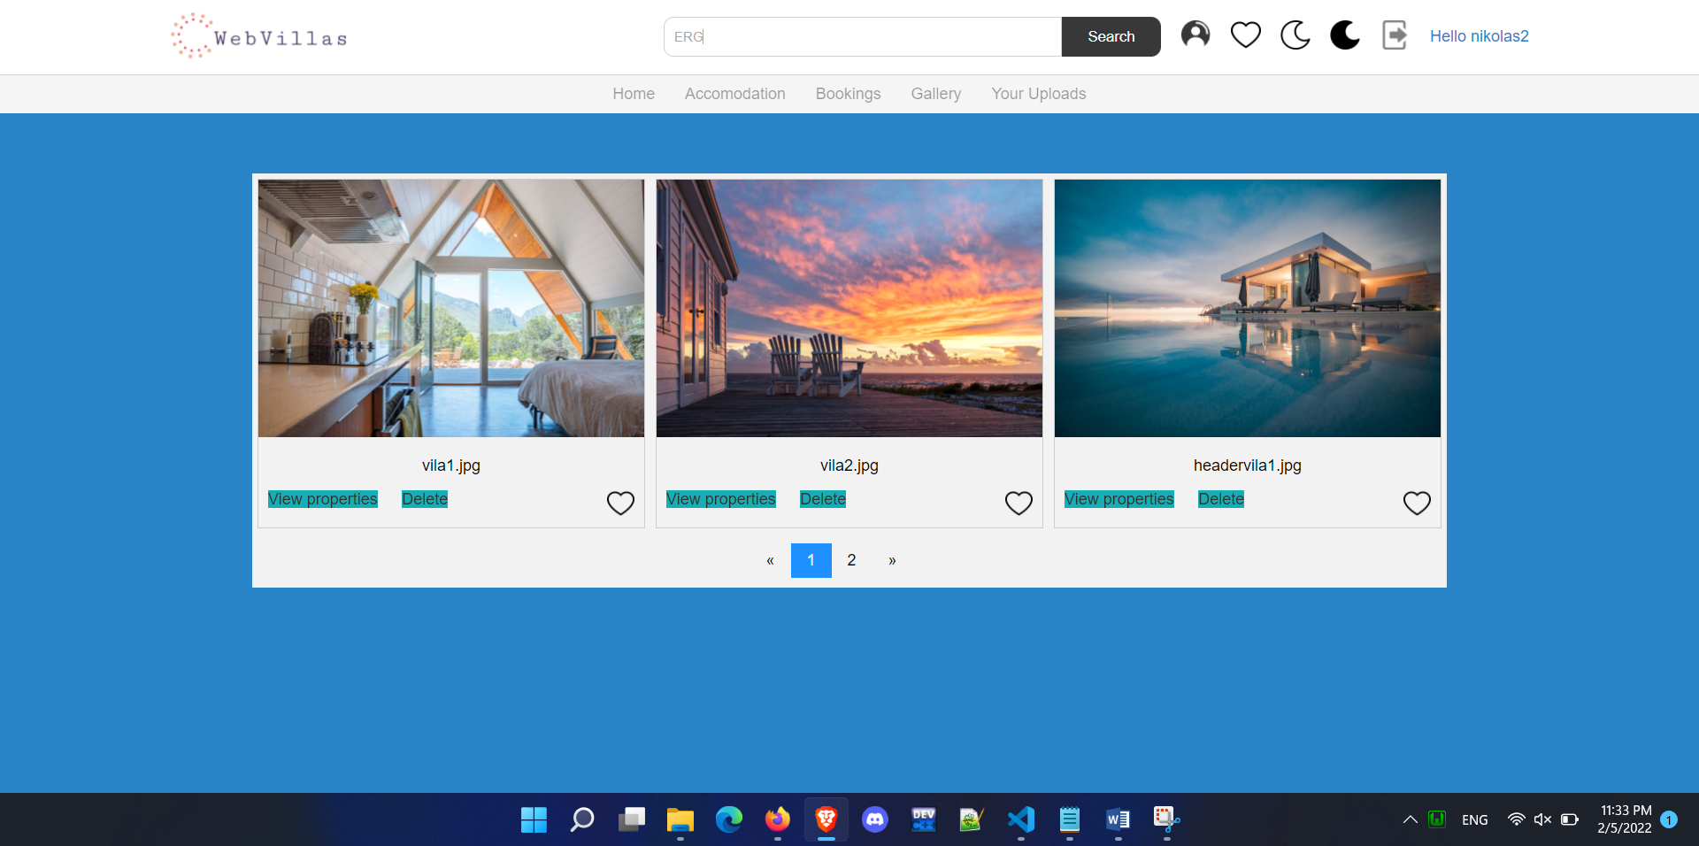

**View Properties of villa 2**

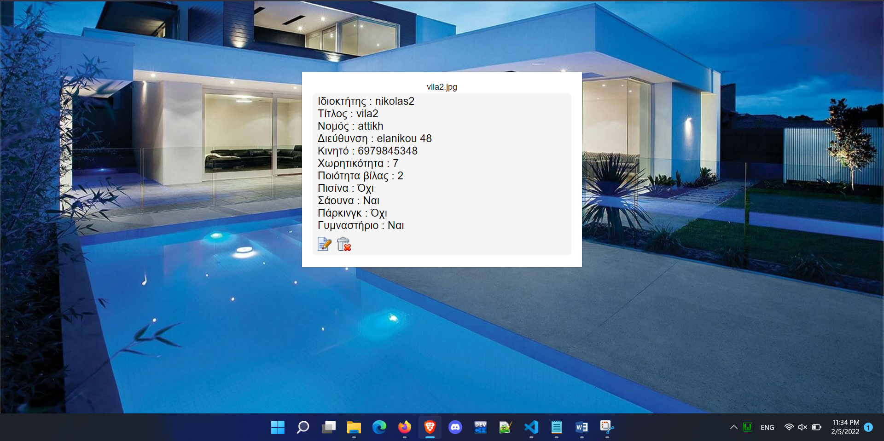

**Edit vila 2**

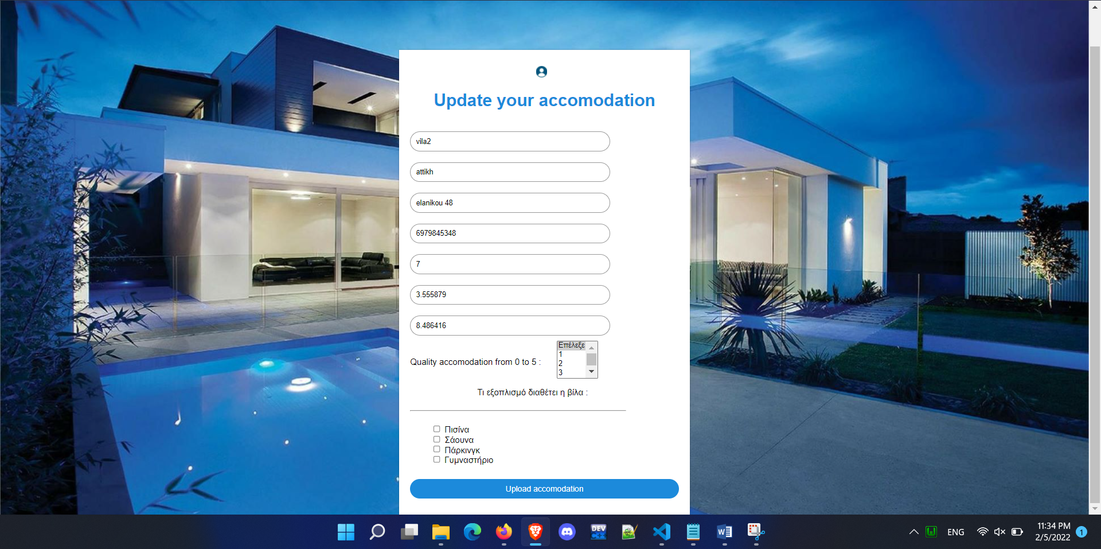

**Upload Image**

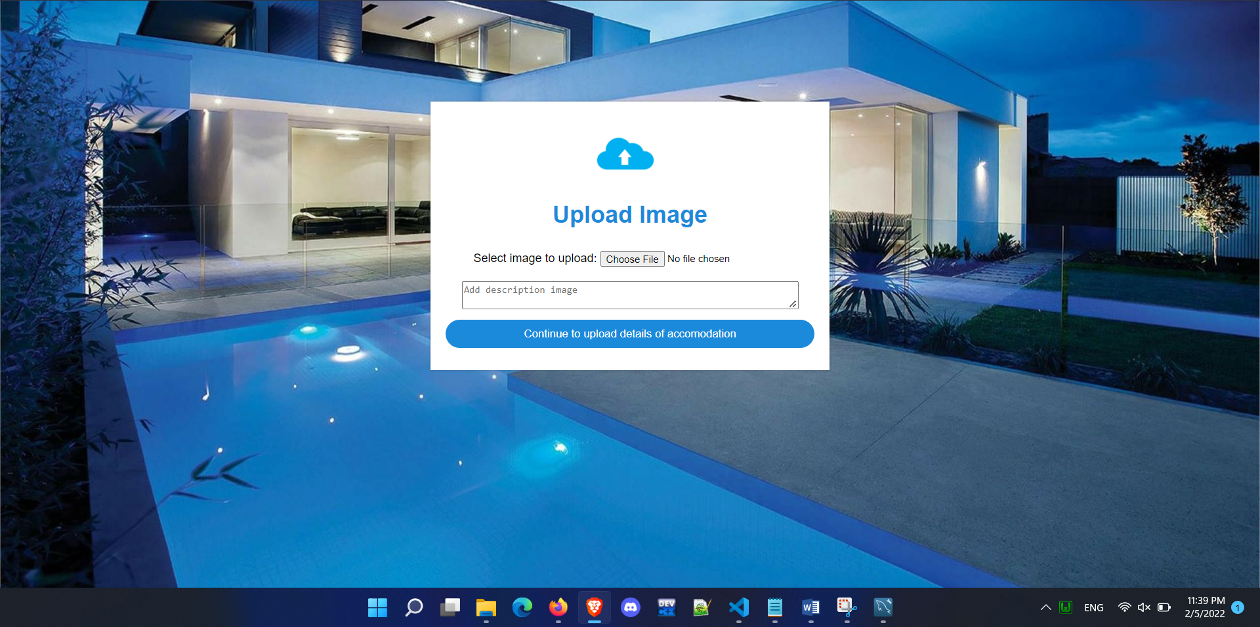

**Upload Image – file exist**

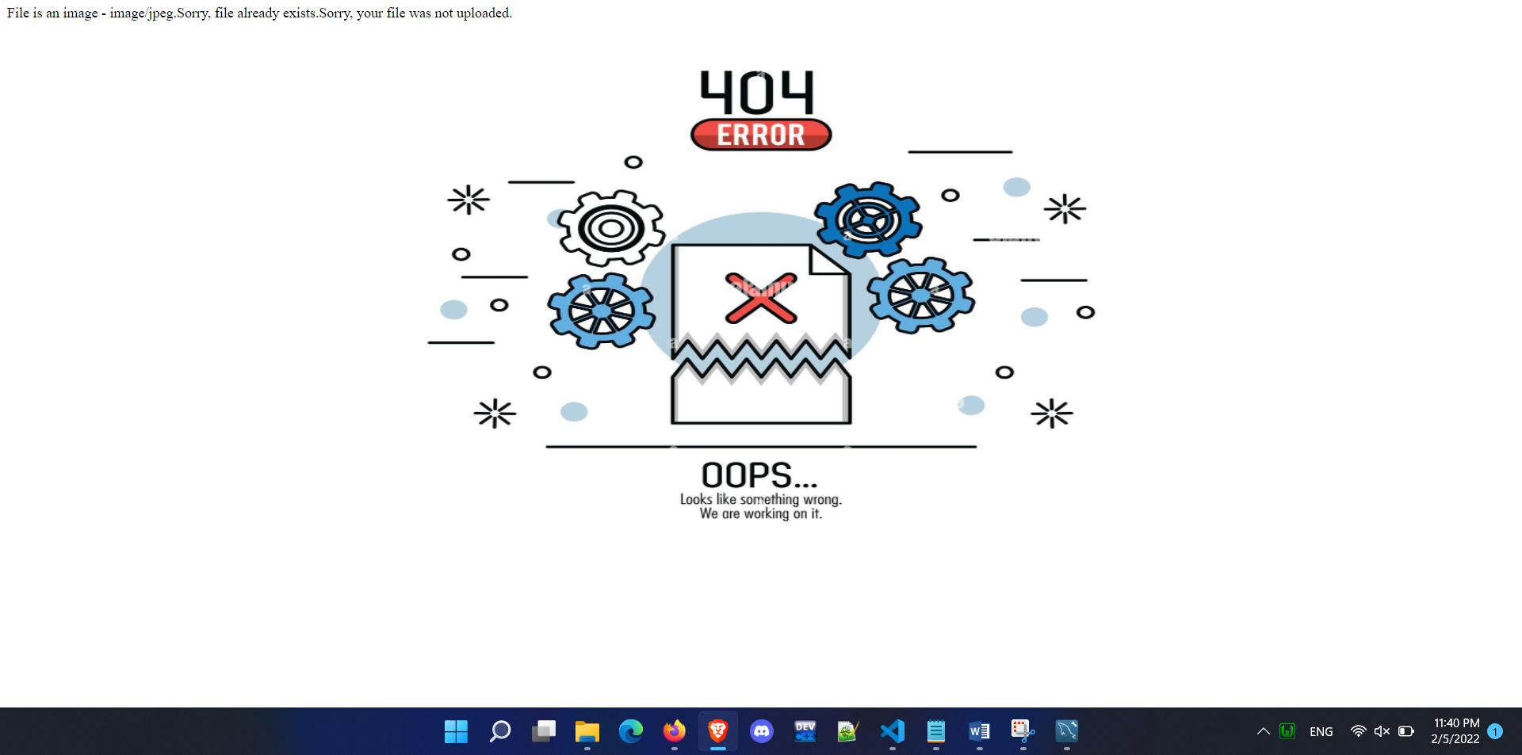

**Upload image – error image is not jpg**

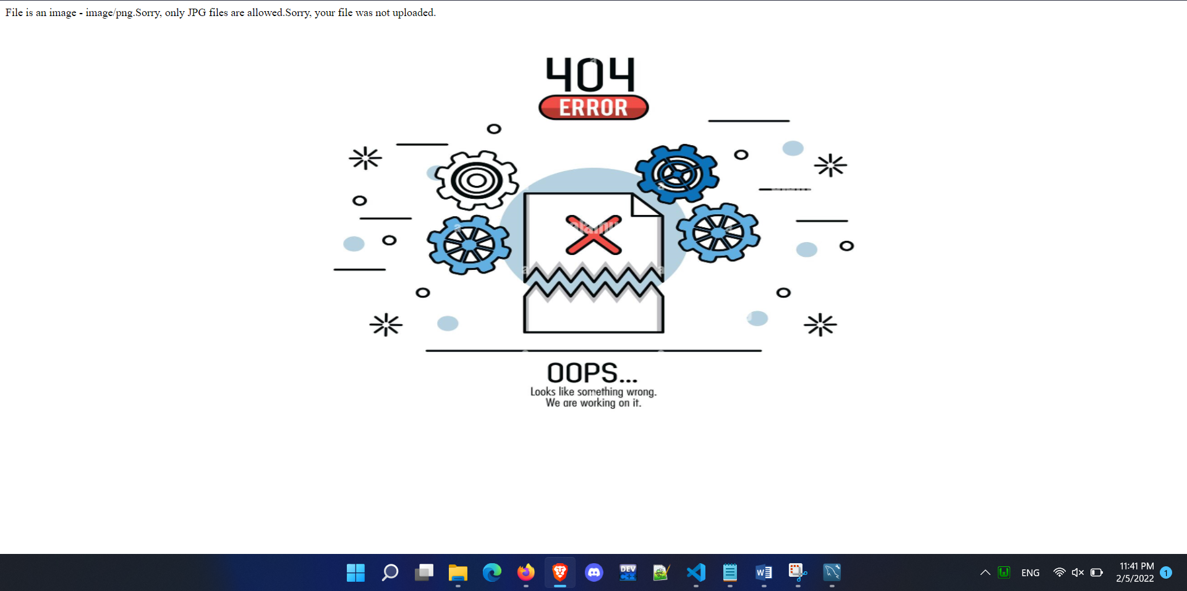

**Show or Upload**

